若有任何疑問，請洽各事業單位訓練發展窗口If you have courses inquiry, Please contact HR as below：
單位 | TD 窗口 | 分機 | E-mail
第一事業處BU1、第二事業處BU2 | 張倪禎 Nica | #21582 | ⁠chang.nica@inventec.com
新事業群NBG、品保客服中心QSC、供應鏈事業處SCBU、永續辦公室Sustainability Office | 余佩倫 Yvonne | #21832 | yu.yvonne@inventec.com
技術中心TC、PSG技術委員會PSG Technical Committee、策略中心Strategy Center | 李梅君 Sherry | #28450 | lee.sherry@inventec.com
稽核中心AC、財務中心FD、人才暨管理中心TAMC、法務中心LAD、資訊中心IT | 陳吟綺 Villa | #28418 | chen.villa@inventec.com
其他單位Others | 金蓓瑩 Albee | #21984 | kim.albee@inventec.com

Hi «英文名»,

您的 «藍圖名稱» 藍圖完訓率已達 «完訓率»。
您已完成 «已完成課程數» 堂， 尚有 «未完成課程數» 堂課程未完成。
E-Learning數位學習平台https://elearning.inventec.com/dist/#/index展開左上方「≡」功能列→ 我的學習護照→ 訓練藍圖
底下附圖亦提供您藍圖課程的完訓確認步驟，謝謝！
* 課程通過標準：
- 每堂課程影片皆有設定完訓時數標準，第一次觀看請勿使用倍速撥放。倍速撥放功能僅提供複習使用！
- 如課程內有包含測驗，須完成且通過測驗後才視為完訓。

Hi «英文名»,

Your «藍圖名稱» training roadmap completion rate is now at «完訓率».
You’ve completed «已完成課程數» course(s) and have «未完成課程數» course(s) left to finish.
Please check the E-Learning platform for more information regarding the course qualifications.
To access E-Learning, visit https://elearning.inventec.com/dist/#/indexYou may find the "≡" function bar on the left, then navigate to My Learning Passport and select the Training Roadmap
You will also find an attachment below with a guide on how to confirm course completion for your reference. Thank you!
Course Completion Rules:
- Each course video has a designated viewing time that must be completed to finish the training. The speed-up feature is intended for review purposes only. Please avoid using it during your initial viewing to ensure that you fully understand the content.
- Please remember to complete any tests that accompany the courses.

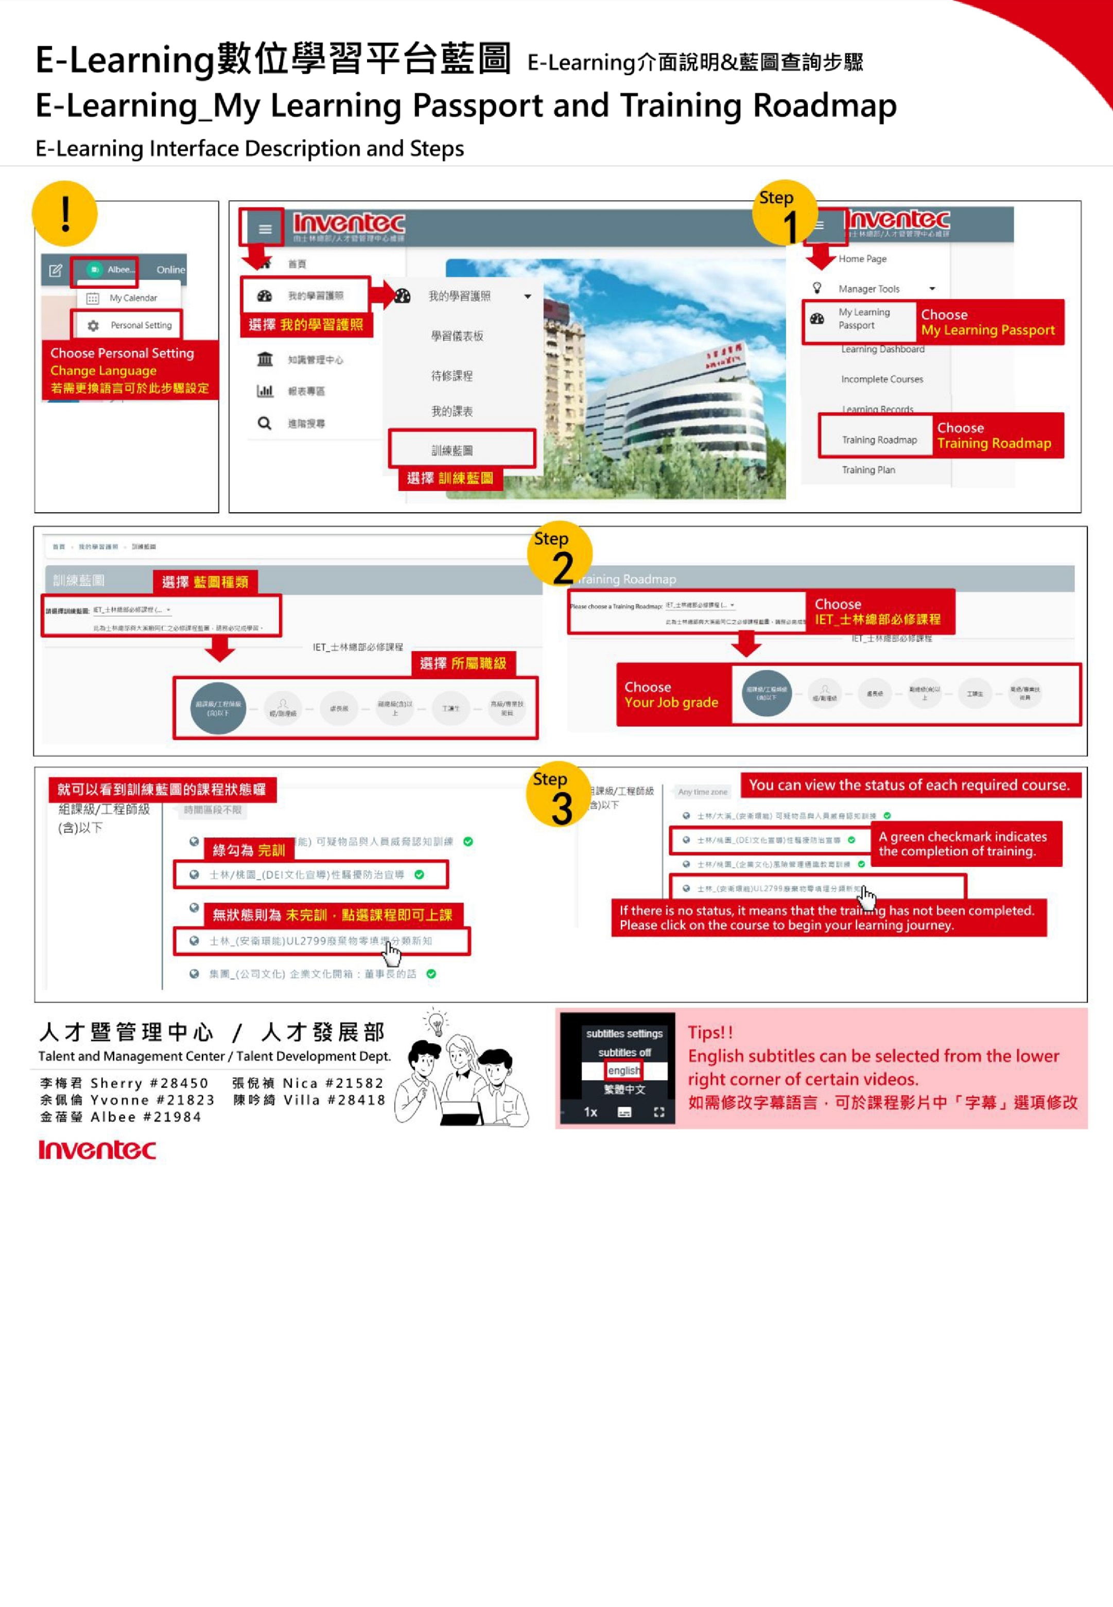

人才暨管理中心 / 人才發展部
Corporate Talent and Management Center/Talent Development Department

